MasterCard Personal Expense Management System (MPEMS)
Project Plan
Filing Reference : | MPEMS_PM-1.2.1
Document Title : | Project Plan
Version : | 1.0
Prepared By : | Lee Zhong De Rollei, Guo Yu
Date Created : | 25 Feb 2012
Review By :
 | Lee Zhong De | Date
 | Project Manager
Accepted By :
 | Huang Donghao | Date
 | Project Client
©1993 ISS.  The information contained in this document is the property of ISS. The contents must not be reproduced, wholly or in part, for purposes other than for which it has been supplied, without the prior permission of ISS, or, if it has been furnished under contract to another party, as expressly authorised under that contract. ISS shall not be liable for any errors or omissions. | ISS
TABLE OF CONTENTS
1. INTRODUCTION 5
1.1 Project Client Back Ground 5
1.2 Purpose 6
1.3 Audiences 6
1.4 Document Organization 7
1.5 References 7
2. WORK PLAN 8
2.1 Activity 1 – Project Planning & Quality Planning 9
2.2 Activity 2 – Requirements Gathering and 9
2.3 Activity 3 – First Quality Audit Meeting 9
2.4 Activity 4 – First Project Presentation 9
2.5 Activity 5 – Analysis Modeling 9
2.6 Activity 6 – High-level Design Modeling 10
2.7 Activity 7 – Prototype 10
2.8 Activity 8 – Second Quality Audit Meeting 10
2.9 Activity 9 – Second Project Presentation 10
2.11 Activity 11 – Implementation 11
2.12 Activity 12 – System Testing 11
2.13 Activity 13 – User Acceptance Testing 11
2.14 Activity 14 – Project Closure 11
2.15 Activity 15 – Third Quality Audit Meeting 11
2.16 Activity 16 – Third Presentation 12
3. PROJECT APPROACH 13
3.1 Project Planning 13
3.2 Requirements Gathering 14
3.3 Analysis Modeling 14
3.4 Design Modeling 14
3.5 Software implementation 15
3.6 Software Testing 15
4. STAFF EFFORT ESTIMATION 16
4.1 Estimated Effort based on COCOMO 16
4.2 Estimated Project Effort based on WBS 17
5. TIMESCALES & MILESTONES 18
5.1 WBS Activities Timescale 18
5.2 Project Milestones 19
6. PROJECT DELIVERABLES 21
7. PROJECT STRUCTURE AND STAFFING 22
8. PROJECT RESOURCES 24
9. RISK ASSESSMENT 25
10. APPENDICES 27
10.1 Functional Point Count 27
10.2 COCOMO Function Points (Admin and Member Module) 36
10.3 COCOMO Value Adjustment Factor 37
10.4 COCOMO Scaling Factor 39
10.5 COCOMO Cost Drive 40
10.6 Detailed Work Breakdown Structure – Resources Allocation 41
10.7 Detailed Work Breakdown Structure – Task Details 46
10.8 Detailed Work Breakdown Structure – Gantt chart 50
10.9 Risks Questionnaires 54
10.10 Risks Techniques 56
11. Approval Record 58
12. Amendment History 59

Revision History:

Version | Date | Author | Remarks
0.1 | 18 Mar 2012 | Lee Zhong De Rollei | Initial Draft
0.1a | 25 Mar 2012 | Lee Zhong De Rollei | Refer to amendment history (Section 12)
0.1b | 30 Mar 2012 | Guo Yu | Refer to amendment history (Section 12)
1.0 | 01 Apr 2012 | Lee Zhong De Rollei | Refer to amendment history (Section 12)

Distribution:
Name | Department | Organization
Huang Donghao | Master Card | Master Card
Dao Xuan Dung | S2 | ISS
Lee Zhong De Rollei | S2 | ISS
Alvin Lee | S2 | ISS
Guo Yu | S2 | ISS
Zhou ZiFeng | S2 | ISS
Jiang Hao Min | S2 | ISS

- INTRODUCTION

This project is an academic project supported by Institute of System Science (ISS, NUS). The project client is MasterCard Singapore. The project seeks to develop a system which will provide additional value added services to MasterCard customers. The value added services provided by the new system will enhance customer’s experience with MasterCard and ideally prompt the customers to choose MasterCard as their preferred card.

  - Project Client Back Ground

Throughout the world, MasterCard’s principal business is to process payments between the banks of merchants and the card issuing banks or credit unions of the purchasers who use the "MasterCard" brand debit and credit cards to make purchases.

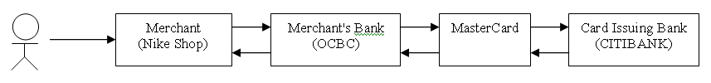

Currently if a customer holds multiple MasterCard from different banks, they will have to manually check their individual card transactions from their card respective banks which can be very inconvenient and time consuming.

The MasterCard Personal Expense Management System seeks to provide the following value added services to all MasterCard holders

- Single point for user to check all their credit/debit cards transactions that are tie to MasterCard Payment Network

- Expense Tracker, allow user to track and analyze their expenses

- Budget Assistance, allow users to organize their budgets and set reminder when their spending exceed their pre-defined budget

- Exclusive MasterCard Deals, allow users to receive exclusive deals only for MasterCard users

- Rewards Program, allow users to earn reward points by spending on their MasterCard. The reward points can be used to exchange vouchers.

  - Purpose

The purpose of this document is to provide the following basis below to the project client and relevant stake holders (e.g. ISS adviser, project team) on how the project will be delivered.

- Goal and objective of the project

- list of tasks that will be undertaken by the project members to fulfill the project requirements

- strategy and approach on how the tasks will be executed by when and by whom

- project milestones and check points to meet, to ensure project progression

- justification of the project efforts required to fulfill the overall project requirements

- risk assessment

  - Audiences
- Project Team. This document will provide the following information to the team
  - A plan for the activities that they need to perform
  - The deliverables the team would require to produce
  - Indicate the required effort and timescales for each task that are allocated to them

- Huang Donghao: He is the project’s client and is required to review and accept the specified requirements of the software in this document to ensure that all the user requirements have been addressed.

- ISS Mentors: This project will be mentored by ISS advisers and this document will be subjected for the advisers’ review.

  - Document Organization

The document is divided into 10 sections.

- Section 1 provides the project introduction and the project background
- Section 2 describes the work plan the project team will undertake to fulfill the project
- Section 3 describes the approach the project team will take to complete the work plan in section 2
- Section 4 provides the estimated staff effort for the project
- Section 5 provides the timeline and major project milestones to meet
- Section 6 list down the deliverables the team will have to produce at different phases of the project
- Section 7 describes the project team structure
- Section 8 defines the hardware and software resource that will be used in this project
- Section 9 describes and risk assessment of the project
- Section 10 contains all the appendices to support the main content of this document

  - References
To fully understand the background to this project, the reader should also be familiar with:
1. MPEMS Requirements Specifications, reference [MPEMS_t-1.2]
2. MPEMS Quality Plan, reference [MPEMS_PM-1.3.1]
2. WORK PLAN

This section defines the project’s overall work plan. It provides the list of activities that have been planned at different phases of the project.

SN | Phase | Activities
1 | Project Planning | Activity 1: Project Planning & Quality Planning  Activity 2: Requirement Gathering & Analysis  Activity 3: First Quality Audit Meeting  Activity 4: First Project Presentation
2 | Analysis and Design | Activity 5: Analysis Modeling  Activity 6: High-Level Design Modeling  Activity 7: Prototyping  Activity 8: Second Quality Audit Meeting  Activity 9: Second Project Presentation
3 | Implementation | Activity 10: Detailed Design Modeling  Activity 11: Implementation  Activity 12: System Testing  Activity 13: User Acceptance Testing  Activity 14: Project Closure  Activity 15: Third Quality Audit Meeting  Activity 16: Third Project Presentation

The description of each activity in the work plan is as follow:

2.1 Activity 1 – Project Planning & Quality Planning

The project will officially kick start after the initial kick-off meeting with the project client. The Project Manager and Quality Manager of the project will proceed to produce a project plan and quality plan based on the high level requirements gathered during the kick off meeting. At the end of this activity, the project and quality plan must be produced. The finalized project plan will be sent to the project client. The project plan will provide information such as project timeline, efforts and activities which the client need to know.

2.2 Activity 2 – Requirements Gathering and

This activity will kick start together with project planning and quality planning. The project business analyst will produce an initial draft of the requirement specifications based on the high-level requirements gathered during kick off meeting. More detailed requirements will be gathered through user interviews. At the end of this activity, the requirement specifications must completed and signed off by the project client.

2.3 Activity 3 – First Quality Audit Meeting
At the end of activity 1 and 2, a quality audit meeting will be conducted to verify that the project team has produced adequate quality planning to address potential issues which may impact the quality of the project deliverables. The meeting will also verify that the project team is adhering to the quality plan when executing the project tasks. All quality audit findings discovered during the meeting must to be addressed in the subsequent phases of the project.

2.4 Activity 4 – First Project Presentation

One week after the first audit meeting, the team is required to present all the work done during phase 1 of the project. The presentation should last approximately 30 minutes, followed by up to 15 minutes for question and answer. The presentation should include: project background; overview of user requirements; project risks & technical challenges; plans (estimates etc) & strategies; progress report.

2.5 Activity 5 – Analysis Modeling

After the project plan, quality plan and requirement specifications have been reviewed and supported by ISS mentors and project client. The project team will proceed with the analysis modeling phase.

The initial task in this activity is to translate user requirements into UML notation. The second task in this activity is to create a User Interface Design Specification (UDIS). This will be done concurrently with activity 6 by the business analyst and solution architect. At the end of this activity, a finalized functional specification must be produced

2.6 Activity 6 – High-level Design Modeling

This activity will kick start with User Interface Design as soon as the USMS and UCRR has been reviewed and finalized. This activity will define the high-level system architecture and also propose a strategy to translate requirements specifications to design specifications. At the end of this activity a high level design specification must be produced.

2.7 Activity 7 – Prototype

After the high-level design specifications have been produced from activity 6, a prototype will be built to explore and verify the proposed software architecture and transition strategy. The prototype will be carefully studied and reviewed by the user manager, business analyst, quality manager and project manager. All findings, suggestions and comments from the prototype study will be documented. The prototype study document will be reviewed and any necessary adjustments to the design will be updated to the high-level design specifications.

2.8 Activity 8 – Second Quality Audit Meeting
After the analysis and high level design modeling is completed. The team will be subjected to a second quality audit check. This activity is to verify that the project team has continuously executed the project task based on quality plan. All quality audit findings discovered during the meeting must to be addressed in the subsequent phases of the project.

2.9 Activity 9 – Second Project Presentation

One week after the second audit meeting, the team is required to present all the work done during phase 2 of the project. The presentation should include: analysis of requirements; software architecture; transition from analysis to design, implementation issues; progress report against the plans (planned versus actuals).

2.10 Activity 10 – Detailed Design Modeling

After the functional and high-level design specifications have been reviewed and supported by ISS mentors and project client. The project team will proceed with the detailed design modeling phase.

This activity will translate analysis models defined in the analysis phase to design models based on the architecture proposed in the high-level design specifications. Only the main use cases of the system will be covered in the detailed design specifications. The detailed design specifications should also include the programmers’ guideline as part of the appendices. At the end of this activity, a reviewed and finalized detailed design specification must be produced.

2.11 Activity 11 – Implementation

Once the detailed design modeling has been completed. Majority of the team member will proceed to program the application based on the detailed design specification. Each team member will be tasked to program a module and conduct it ensuing unit testing. At the end of the coding and unit testing phase, the team will perform peer review on one another’s code. All corrective action will have to be done during the peer review.

2.12 Activity 12 – System Testing

This activity will kick start together with Activity 11. The first task in this activity is to create test script and test plan. The system test will commence immediately after the completion of implementation. The system test will be conducted internally by the team’s project manager and test manager. All observations and bugs encountered during the testing will be documented for further review. All corrective actions will be undertaken after the system test review.

2.13 Activity 13 – User Acceptance Testing

Once the system has been adequately tested internally by the project team, the solution architect will proceed to setup a separate UAT environment. The project manager, quality manager and business analysis will schedule a pre-uat briefing with the tester. During the briefing, the business analyst will walk through the system with the testers and also brief the tester on bugs report procedures. After which the testers will be given 1 week to test the system. No formal test session will be scheduled, the testers will test the system as and when they’re available. After the first UAT cycle is completed, the bugs will be collated for review. The review will determine if there will be any corrective actions to be taken. A regression testing to verify the corrective actions will then be conducted. At the end of UAT, all test results and action taken to correct the problem will be documented in a formal Test Result Document.

2.14 Activity 14 – Project Closure

Once the UAT has completed, the project team will proceed to create the user guide for the system and also final project report. Upon the completion of the user guide, the project manager will schedule a project closure meeting with the project client. During the closure meeting, the client will formally sign off the project and all source codes and documents related to the project will be handed over to the client. At the end of this activity, the project will be signed-off, the final project report must also be completed

2.15 Activity 15 – Third Quality Audit Meeting

The final Quality Audit Meeting will be conducted to conclude the project quality adherence during the project.

2.16 Activity 16 – Third Presentation

The last activity in the work plan is the final presentation which the team is required to present and conclude the project with ISS mentors. The presentation should include: an overview of the project background and requirements; summary development strategy and technical issues; brief demonstration (if possible); report on the overall project progress (planned versus actual); recommendations for further work; lessons learnt by the project team.

The project team is also required to demonstrate the completed system to ISS mentors. When required, the project team may also have to do a code walkthrough with ISS mentors
3. PROJECT APPROACH

This section describes some of the approaches, tools and techniques the project team will use to complete the tasks/activities described in the Section 2 - Work Plan of this document.

3.1 Project Planning
The project will be initiated with a formal project plan. The project plan will define the work plan, project efforts, timeline and the potential risk involved in this project.

A central file repository will be created to store all project documents.

A work breakdown structure (WBS) will be created to list down the activities that will be undertaken by the team member to fulfill the project requirements. Each activities defined in the WBS will be translated into man-day effort by project team’s judgment based on the team’s past experience and resource constraints

To verify the estimation made by the team’s judgment, a separate effort estimation will be conducted using COCOMO, Functional Point Count (FPC). The total effort derived from team’s judgment will be compared against COCOMO derived estimates. If required, necessary adjustments will be made to the WBS activities to average out the estimates from WBS and COCOMO.

Based on the estimated man-days, a project schedule will be produced in Microsoft project. The project schedule will provide the following information:

- total effort (in man days) required for each activity

- the start and end date for each activity

- the number of resource(s) and name of resource allocated to each activity

- average time (in hours) each resource have to spend per day to complete each task

- the interdependencies between activities

- project activity milestones

Risk assessment will also be undertaken as part of the project plan. All potential risks which will impact the success of the project will be identified and prioritized (for monitoring) through risk questionnaires. Techniques/measurements to avoid/mitigate each risk identified will also be defined in the project plan.

3.2 Requirements Gathering
The requirements will be captured through user interviews. A total of 2 interviews session, each lasting 2 – 4 hours will be conducted. After each interviews, the requirements will be captured in a formal requirements specifications. The requirement specifications document will then be sent to the interviewees for verifications and clarifications (if required). After all the requirements have been captured in the requirement specification, the project client will do a formal sign off to acknowledge and accept the requirements specifications.

3.3 Analysis Modeling
The requirements captured in the requirements specifications will be analyzed and translated into Use Case Model Survey (USMS). Major Use Cases defined in USMS will be further analyzed and translated to their respective Use Case Realization Report (UCRR). Around the same time, the solution architect will kick start the system high-level architecture design. Upon the completion of USMS, UCRR and high-level design, a prototype will be built based on the major requirements captured in USMS, UCRR and high-level design.

Together with prototype development, a User Interface Specifications (UIS) will also be created. The prototype created will be studied and tested by the team member together with the project client. All findings discovered during prototype testing will be documented into a Prototype Study Report. If required, adjustments will also be made to the USMS, UCRR and UIS to reflect and critical change of design decision.

The documentations created during the analysis phase will be compiled and re-produced as a Function Specifications which encompasses the analyzed requirements represented in UML and the User Interface design. This document will have to be supported and signed off by the project client.

3.4 Design Modeling
The analyzed requirements captured in the functional specifications will be translated to a detailed design specification. The solution architect will define the transition strategy from analysis to design based on the chosen libraries, platform and tool that will be used to develop the system.

3.5 Software implementation

The system will developed in Java using Eclipse as the IDE. The database to be used will be MySQL. 4 Members from the team will carry out the coding and the remaining 2 member will test the system.

3.6 Software Testing

3 different types of testing will be conducted during the project. These testing include

- Unit test which will be conducted by the programmer
- System test which will be conducted internally by the project team
- User acceptance testing which will be conducted by MasterCard representative

4. STAFF EFFORT ESTIMATION

4.1 Estimated Effort based on COCOMO

The estimated effort for the scope of this project based on COCOMO using Functional Point Count is 12.3 Person-Months which is equivalent to 374 man days.

Programming Language | Java
Translation Factor | 29

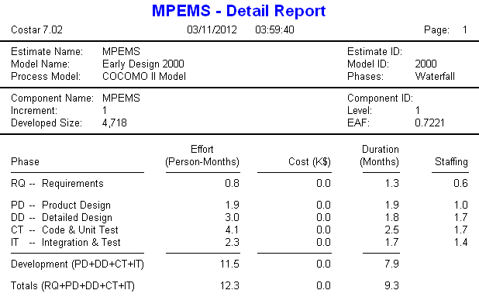

* refer to appendix 10.1 for Functional Point Count
* refer to appendix 10.2 for COCOMO Unadjusted Function Points
* refer to appendix 10.3 for Value Adjustment Factor
* refer to appendix 10.4 for Scaling factor
* refer to appendix 10.5 for Cost Driver

4.2 Estimated Project Effort based on WBS

The estimated effort for the scope of this project based on WBS and project team judgment is 369.5 Man days

Task ID | Task Name | Est. Man Day
1 | Project Planning & Quality Planning | 24
2 | Requirement Analysis | 14
3 | First Quality Audit Meeting | 5
4 | First Project Presentation | 4.5
5 | Analysis Modeling | 66
6 | High Level Design Modeling | 19
7 | Prototype | 33.5
8 | Second Quality Audit Meeting | 5
9 | Second Project Presentation | 4.5
10 | Detailed Design Modeling | 27.5
11 | Implementation | 56
12 | System Testing | 37
13 | User Acceptance Testing | 26.5
14 | Project Closure | 27.5
15 | Third Quality Audit Meeting | 5
16 | Third Project Presentation | 14.5
Total Man Days |  | 369.5

* refer to appendix 10.6 for detailed Work Breakdown Structure – Resources Allocation
* refer to appendix 10.7 for detailed Work Breakdown Structure – Task Details

5. TIMESCALES & MILESTONES

5.1 WBS Activities Timescale
Phase | Activity ID | Task Name | Start Date | Finish Date
Project Planning | 1 | Project Planning & Quality Planning | Fri 2/17/12 | Sun 4/1/12
Project Planning | 2 | Requirement Analysis | Sat 2/25/12 | Sun 4/1/12
Project Planning | 3 | First Quality Audit Meeting | Sat 3/31/12 | Tue 4/3/12
Project Planning | 4 | First Project Presentation | Sun 4/1/12 | Tue 4/10/12
Analysis and Design | 5 | Analysis Modeling | Wed 4/11/12 | Sat 8/11/12
Analysis and Design | 6 | High Level Design Modeling | Sun 5/27/12 | Sat 8/11/12
Analysis and Design | 7 | Prototype | Sun 7/8/12 | Sat 8/11/12
Analysis and Design | 8 | Second Quality Audit Meeting | Sat 8/11/12 | Tue 8/14/12
Analysis and Design | 9 | Second Project Presentation | Sun 8/12/12 | Tue 8/21/12
Implementation | 10 | Detailed Design Modeling | Wed 8/22/12 | Mon 9/10/12
Implementation | 11 | Implementation | Sun 9/2/12 | Sun 9/23/12
Implementation | 12 | System Testing | Sun 9/2/12 | Sun 10/14/12
Implementation | 13 | User Acceptance Testing | Sun 10/14/12 | Sun 12/2/12
Implementation | 14 | Project Closure | Mon 12/3/12 | Fri 1/4/13
Implementation | 15 | Third Quality Audit Meeting | Sat 1/5/13 | Tue 1/8/13
Implementation | 16 | Third Project Presentation | Wed 1/9/13 | Tue 1/15/13

* refer to appendix 10.7 for detailed Work Breakdown Structure – Task Details
* refer to appendix 10.8 for detailed Work Breakdown Structure – Gantt Chart

5.2 Project Milestones

SN | Activity | Approx. Date
1. | Project Planning & Quality Planning
1.4 | Review, Update and Finalize Project Plan | 01 Apr 2012
1.6 | Review, Update and Finalize Quality Plan | 01 Apr 2012
2 | Requirement Analysis
2.3 | Review, Update and Finalize User Requirement Specifications | 01 Apr 2012
3 | First Quality Audit
3.3 | First Quality Audit Meeting | 03 Apr 2012
4 | First Project Presentation
4.2 | First Project Presentation | 10 Apr 2012
5 | Analysis Modeling
5.3 | Review, Update and Finalize USMS | 29 Apr 2012
5.8 | Review, Update and Finalize UCRR | 27 May 2012
5.10 | Review, Update and Finalize UIDS | 30 Jun 2012
5.12 | Completed Functional Specification (FS) | 11 Aug 2012
6 | High Level Design Modeling
6.5 | Review, Update and Finalize High-Level Design Specification | 11 Aug 2012
7 | Prototype
7.2 | Created Prototype | 22 July 2012
7.6 | Review, Update and Finalize Prototyping Reports | 11 Aug 2012
8 | Second Quality Audit
8.3 | Second Quality Audit Meeting | 14 Aug 2012
9 | Second Project Presentation
9.3 | Second Project Presentation | 21 Aug 2012
10 | Detailed Design Modeling
10.7 | Review and Update Detailed Design Specification | 10 Sep 2012
11 | Implementation
11.1 | Completed Coding | 16 Sep 2012
11.2 | Completed Unit Testing | 19 Sep 2012
11.3 | Completed Peer Review | 23 Sep 2012
12 | System Testing
12.2 | Peer Reviewed and Updated Test Plan | 23 Sep 2012
12.4 | Conducted System Testing | 30 Sep 2012
12.8 | Documented System Test Results | 14 Oct 2012
13 | User Acceptance Testing
13.3 | Supported UAT | 24 Oct 2012
13.7 | Documented UAT Test Results | 02 Dec 2012
14 | Project Closure
14.3 | Review, Update and Finalize Final Project Report | 04 Jan 2013
14.4 | Review, Update and Finalize User Guide | 27 Dec 2012
14.5 | Project Closure meeting with project client | 28 Dec 2012
15 | Third Quality Audit Meeting
15.3 | Completed Third Quality Audit | 08 Jan 2013
16 | Third Quality Audit Meeting
16.3 | Completed Third Project Presentation | 15 Jan 2013
* refer to appendix 10.8 for detailed Work Breakdown Structure – Gantt Chart milestones

6. PROJECT DELIVERABLES

As a result of undertaking the work described in the work plan, the following deliverables will be produced at different phase of the project.

SN | Phase | Deliverables
1 | Project Planning | - Project Plan  - Quality Plan  - User Requirement Specification
2 | Analysis and Design | - Functional Specification  - Prototype Study Report  - High-level Design Specification
3 | Implementation | - Detailed Design Specification  - Source and Executable  - Test Documentation  - User Guide  - End of Project Report

7. PROJECT STRUCTURE AND STAFFING

Project Role |  | Personnel | Responsibility
ISS | ISS Mentors | ISS | - Provide project advisory to the project team
PM | Project Manager | Lee Zhong De  Rollei | - Develop Project Plan  - Manage project schedule, risk and change request  - Liaise with Project Stake Holders  - Ensure timely completion of deliverables  - Facilitate User Sign-Off
QM | Quality Manager | Lee Mingjian Alvin | - Develop Quality Plan  - Ensure the quality plans are executed accordingly  - Validate product created meets quality requirements  - Provide advices on matters relating to product quality
BA | Business Analyst | Dao Xuan Dung Thomas | - Develop User Requirement Specifications  - Conduct interviews to gather requirements  - Document meeting minutes  - Assist in Prototype Review, SIT, UAT
SA | Solution Architect | Guo Yu | - Develop Design Specifications  - System Architecture  - Database Design  - Responsible for all installation, deployment and development/test environment setup with the assistant from Implementation Managers
IM | Implementation Manager | Jiang Hao Min, | - Assist Solution Architect to Develop Design Specifications  - Prototype Creation  - Integration of Code Modules  - Source Code Management  - Create Programmer guideline
TM | Test Manager | Zhou Zi Feng | - Create test plan and test scripts  - Prepare and support UAT testing  - Test result documentation
MC | User Manager | Huang Dong Hao | - Provide user requirements  - Review and accept project deliverables
MC | Sr. Software Engineer | Bensam Joyson | - Representative from project client to review the technical design of the system

8. PROJECT RESOURCES

All development work will be undertaken in the project team’s personal notebook. No additional office space will be setup. However, a project server provided by ISS will be used as the centralized application and database server for system and user acceptance testing

Computer Hardware and Software

- Hardware
  - 1 x Server (Provided by ISS)
  - Project Team Member Personal Notebook

- Software
  - Windows Server 2008r2 (pre-installed)
  - Weblogic
  - Java 1.6
  - MySql
  - Eclipse
  - Grails

9. RISK ASSESSMENT

The following potential risks have been identified.
SN | Risk Item | Impact |  |  |  |  |  | Likelihood |  |  |  |  |  | Total
SN | Risk Item | 1 | 2 | 3 | 4 | 5 | Total | 1 | 2 | 3 | 4 | 5 | Total | Total
 | Team member departure and unavailability |  | x | x |  |  | 2 |  |  | x |  |  | 1 | 3
 | Project client commitment to the project and availability | x | x | x | x |  | 4 |  |  | x |  | x | 2 | 6
 | Insufficient hardware resource |  | x | x |  |  | 2 |  |  | x |  |  | 1 | 3
 | System portability risk |  |  |  | x |  | 1 |  | x |  |  |  | 1 | 2
 | Dependency on third-party library and lack of experience in third-party library |  |  |  | x |  | 1 |  | x |  |  |  | 1 | 2
 | Lack of experience in UI design for Mobile Website |  |  |  | x |  | 1 |  | x |  |  |  | 1 | 2
 | Uncertainty/insufficient requirements |  |  |  | x | ‘ | 1 |  |  | x |  |  | 1 | 2

* refer to appendix 10.9 for Risk Questionnaires
* refer to appendix 10.10 for Risk Techniques
Impact Legend | Likelihood Legend
1: Reduced Functionality | 1: Novelty
2: Increased Cost | 2: Product History
3: Schedule Slippage | 3: Project Team History
4: Quality Cost | 4: Recognized Authority
5: Performance | 5: Expectation

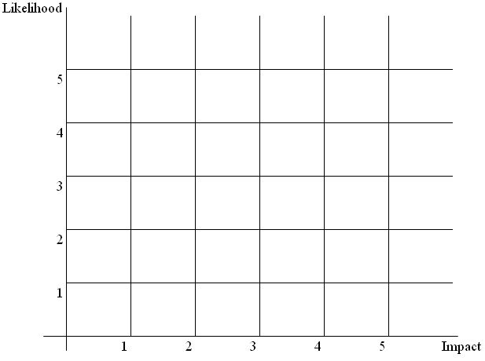
Risk (4, 5, 6, 7)
Risk (1, 3)
Risk (2)
10. APPENDICES

10.1 Functional Point Count

Admin Module Data Function

Internal Logical File/External Interface File |  |  | Elements of complexity
Type | Reference | Description | DET | RET | Complexity
ILF | URS 3.3 | Administrator Login | 3 | 1 | L
 |  | Login ID
 |  | Login Password
 |  | Administrator Name
ILF | URS 3.7.1 | Deals Details | 8 | 1 | L
 |  | Deal ID
 |  | Deal Title
 |  | Deal Description
 |  | Deal Start date
 |  | Deal End Date
 |  | Deal Image File Link
 |  | Deal Category
 |  | Deal Meta Tags
ILF | URS 3.10.1 | Voucher Details | 7 | 1 | L
 |  | Voucher ID
 |  | Voucher Title
 |  | Voucher Description
 |  | Redemption Points
 |  | Voucher Image Link File
 |  | Voucher Category Type
 |  | Quantity
ILF | URS 3.8 | Redemption Details | 7 | 1 | L
 |  | Redemption ID
 |  | Login ID
 |  | Redemption Date
 |  | Voucher ID
 |  | Quantity
 |  | Address Gift Voucher to Sent
 |  | Redemption Status
ILF | URS 3.11 | Merchant Details | 5 | 1 | L
 |  | Merchant ID
 |  | Merchant Name
 |  | Merchant Address
 |  | Merchant Contact
 |  | Merchant Category
ILF | URS 3.8 | Transaction Category | 2 | 1 | L
 |  | Transaction Category ID
 |  | Transaction Name

Admin Module Transaction Function

External Input/External Output/External Inquiry |  |  | Elements of complexity
Type | Reference | Description | DET | FTR | Complexity
EI | URS 3.7.1 | Create MasterCard Deals | 8 | 1 | L
 |  | Deal ID
 |  | Deal Title
 |  | Deal Description
 |  | Deal Start date
 |  | Deal End Date
 |  | Deal Image File Link
 |  | Deal Category
 |  | Deal Meta Tags
EI | URS 3.7.1 | Update MasterCard Deals Details | 8 | 1 | L
EI | URS 3.7.1 | Delete MasterCard Deal | 1 | 1 | L
 |  | Deal ID
EI | URS 3.10 | Create Voucher | 7 | 1 | L
 |  | Voucher ID
 |  | Voucher Title
 |  | Voucher Description
 |  | Redemption Points
 |  | Voucher Image Link File
 |  | Voucher Category Type
 |  | Quantity
EI | URS 3.10 | Update Voucher Details | 7 | 1 | L
EI | URS 3.10 | Delete Voucher | 1 | 1 | L
 |  | Voucher ID
EI | URS 3.9 | Update Member Status | 2 | 1 | L
 |  | Login ID
 |  | Status (active, inactive, suspended)
EI | URS 3.10 | Update Redemption Status | 2 | 1 | L
 |  | Redemption ID
 |  | Status
EQ | URS 3.3 | Secured Login |  |  | L
 |  | Input | 2 | 1
 |  | Login ID
 |  | Password
 |  | Output
 |  | -
EQ | URS 3.7.1 | Search and View MasterCard Deals |  |  | L
 |  | Input | 2 | 1
 |  | Key Word
 |  | Category
 |  | Output | 7 | 1
 |  | Deal ID
 |  | Deal Title
 |  | Deal Description
 |  | Deal Start date
 |  | Deal End Date
 |  | Deal Image File Link
 |  | Deal Category
EQ | URS 3.10 | Search and View Vouchers |  |  | L
 |  | Input | 2 | 1
 |  | Search Criteria
 |  | Search Value
 |  | Output | 6 | 1
 |  | Voucher ID
 |  | Voucher Title
 |  | Voucher Description
 |  | Redemption Points
 |  | Voucher Image Link File
 |  | Voucher Category Type
 |  | Quantity
EQ | URS 3.8 | Search and View Redemptions |  |  | A
 |  | Input | 2 | 1
 |  | Search Criteria
 |  | Search Value
 |  | Output | 7 | 2
 |  | Redemption ID
 |  | Redemption Date
 |  | Customer Name
 |  | Voucher ID
 |  | Quantity
 |  | Address Gift Voucher to Sent
 |  | Quantity
EQ | URS 3.9 | Search and View Members |  |  | A
 |  | Input | 2 | 1
 |  | Search Criteria
 |  | Search Value
 |  | Output | 9 | 2
 |  | Login ID
 |  | Name
 |  | Mobile Number
 |  | Email Address
 |  | Home Address
 |  | Reward Points
 |  | Status (active, inactive, suspended)
 |  | Login Attempts
 |  | Credit Card(s)

Member Module Data Function

Internal Logical File/External Interface File |  |  | Elements of complexity
Type | Reference |  | DET | RET | Complexity
ILF | URS 3.1.1.1 | Member Details | 6 | 1 | L
 |  | Login ID
 |  | Login Password
 |  | Name
 |  | Mobile Number
 |  | Email Address
 |  | Home Address
ILF | URS 3.1.1.2 | Credit Card Details | 9 | 1 | L
 |  | Name on the Credit Card
 |  | Credit Card Number
 |  | Credit Card Expiry Date
 |  | Credit Card CVV2
 |  | Credit Card Issuer Bank
 |  | Credit Card Country
 |  | Daily Budget
 |  | Weekly Budget
 |  | Month Budget
ILF | URS 3.5.1 | Transaction Details | 9 | 1 | L
 |  | Merchant ID
 |  | TxnType
 |  | TxnDateTime
 |  | Acct - Credit Card Number
 |  | ExpDate
 |  | Amount
 |  | Currency
 |  | Cvv2
 |  | Category
ILF | URS 3.8 | Redemption Details | 6 | 1 | L
 |  | Redemption ID
 |  | Redemption Date
 |  | Voucher ID
 |  | Quantity
 |  | Address Gift Voucher to Sent
 |  | Redemption Status

Member Module Transaction Function

External Input/External Output/External Inquiry |  |  | Elements of complexity
Type | Reference | Description | DET | FTR | Complexity
EI | URS 3.1 | Account Registration | 15 | 2 | A
 |  | Login ID
 |  | Login Password
 |  | Name
 |  | Mobile Number
 |  | Email Address
 |  | Home Address
 |  | Name on the Credit Card
 |  | Credit Card Number
 |  | Credit Card Expiry Date
 |  | Credit Card Cvv2
 |  | Credit Card Issuer Bank
 |  | Credit Card Country
 |  | Daily Budget
 |  | Weekly Budget
 |  | Month Budget
EI | URS 3.4 | Update Account Details | 4 | 1 | L
 |  | Name
 |  | Mobile Number
 |  | Email Address
 |  | Home Address
EI | URS 3.2 | Reset Password | 1 | 1 | L
 |  | Login ID
EI | URS 3.4 | Change Password | 2 | 1 | L
 |  | Old Password
 |  | New Password
EI | URS 3.4 | Add new MasterCard to Account | 9 | 1 | L
 |  | Name on the Credit Card
 |  | Credit Card Number
 |  | Credit Card Expiry Date
 |  | Credit Card Cvv2
 |  | Credit Card Issuer Bank
 |  | Credit Card Country
 |  | Daily Budget
 |  | Weekly Budget
 |  | Month Budget
EI | URS 3.4 | Subscribe/Unsubscribe to Deal Category | 2 | 2 | L
 |  | Login ID
 |  | Deal Category
EI | URS 3.5 | Assign Transaction to specific Category | 2 | 1 | L
 |  | Transaction ID
 |  | Category ID
EI | URS 3.6 | Assign Budget to individual Card | 4 | 1 | L
 |  | Credit Card Number
 |  | Daily Budget
 |  | Weekly Budget
 |  | Monthly Budget
EI | URS 3.8 | Redeem Voucher | 3 | 2 | L
 |  | Voucher ID
 |  | Quantity
 |  | Address Gift Voucher to Sent
EI | URS 3.6 | Assign Overall Budget | 2 | 1 | L
 |  | Period (weekly/monthly)
 |  | Budget
EO | URS 3.1 | Registration Email Confirmation | 6 | 2 | A
 |  | Name
 |  | Mobile Number
 |  | Email Address
 |  | Home Address
 |  | Credit Card Number (Masked)
 |  | Confirmation Message
 |  | Confirmation Link
EO | URS 3.1 | Registration SMS Notification | 3 | 2 | L
 |  | Name
 |  | Credit Card Number (Masked)
 |  | Notification Message
EO | URS 3.6 | Budget Exceed SMS Notification | 6 | 2 | A
 |  | Name
 |  | Credit Card Number (Masked)
 |  | Total Spending
 |  | Budget
 |  | Period
 |  | Notification Message
EO | URS 3.4 | Password Change SMS Notification | 2 | 1 | L
 |  | Name
 |  | Notification Message
EO | URS 3.3 | Fail Login SMS Notification | 3 | 1 | L
 |  | Name
 |  | Login ID
 |  | Notification Message
EQ | URS 3.3 | Secured Login |  |  | L
 |  | Input | 2 | 1
 |  | Login ID
 |  | Password
 |  | Output
 |  | -
EQ | URS 3.5 | View My MasterCards |  |  | L
 |  | Input | 2 | 1
 |  | Login ID
 |  | Output | 6 | 1
 |  | Name on the Credit Card
 |  | Credit Card Number
 |  | Credit Card Expiry Date
 |  | Credit Card CVV2
 |  | Credit Card Issuer Bank
 |  | Credit Card Country
EQ | URS 3.5 | Search and View Transaction |  |  | A
 |  | Input | 3 | 1
 |  | Credit Card Number
 |  | Search Criteria
 |  | Search Value
 |  | Output | 7 | 3
 |  | Merchant Name
 |  | TxnType
 |  | TxnDateTime
 |  | Acct - Credit Card Number
 |  | Amount
 |  | Currency
 |  | Category
EQ | URS 3.5 | View Reports Graphs |  |  | L
 |  | Input | 3 | 1
 |  | Type Of Report
 |  | Start Date
 |  | End Date
 |  | Output | 2 | 1
 |  | X Coordinates
 |  | Y Coordinates
EQ | URS 3.7 | Search and View MasterCard Deals |  |  | L
 |  | Input | 2 | 1
 |  | Key Word
 |  | Category
 |  | Output | 7 | 1
 |  | Deal ID
 |  | Deal Title
 |  | Deal Description
 |  | Deal Start date
 |  | Deal End Date
 |  | Deal Image File Link
 |  | Deal Category
EQ | URS 3.10 | Search and View Vouchers |  |  | L
 |  | Input | 2 | 1
 |  | Key Word
 |  | Category
 |  | Output | 6 | 1
 |  | Voucher ID
 |  | Voucher Title
 |  | Voucher Description
 |  | Redemption Points
 |  | Voucher Image Link File
 |  | Voucher Category
EQ | URS 3.8 | Search and View Redemptions |  |  | A
 |  | Input | 2 | 1
 |  | Search Criteria
 |  | Search Value
 |  | Output | 5 | 2
 |  | Redemption Date
 |  | Voucher ID
 |  | Voucher Title
 |  | Address Gift Voucher to Sent
 |  | Quantity Redeemed

10.2 COCOMO Function Points (Admin and Member Module)

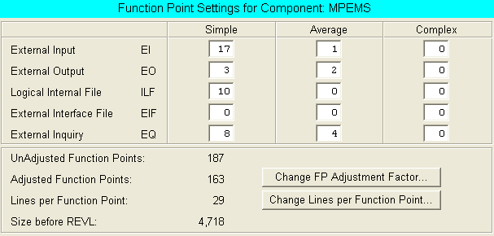

10.3 COCOMO Value Adjustment Factor

CHARACTERISTIC | DI | Remarks
Data Communications | 4 | The new system will use client server model where multiple clients will concurrently query the server to download data. However, the server will not initial a connection to the client. The expected number of subscribers may cross 100,000.
Distributed Functions | 3 | The system will use n-tier architecture design where some of the data processing capabilities will spread across different computers. E.g. Application may first process the data and send the processed data to its database. At the database, the data may further be processed before the data is been stored in the database.
Performance | 3 | There is a quality requirements where the response time for each page should not exceed x seconds. The system must be properly designed (load on demand via AJAX) to ensure that the web page will not be too heavy to load. The system is also targeted to be run on mobile devices connecting via 3G network; as such a separate mobile site will be created. The mobile site will have minimal image content to ensure the page can still be loaded with slower bandwidth.
Heavily Used Configuration | 0 | No explicit or implicit operational restrictions are included.
Transaction Rate | 0 | The users will use the system as and when required. There is no peak transaction period anticipated
On-Line Data Entry | 2.5 | Around 40% of the transactions are data entry. The remaining transactions are mainly data retrieving which do not involve data entry.
End User efficiency | 2.5 | System will be displayed on different device. A desktop screen typically is17” and a handheld screen typical 3.5”. The system must be carefully designed to achieve user friendliness
On-line Update | 2.5 | 40% of the system data is modifiable by users. However, as of the current requirements there is no need for special measurements that need to be put in place to protect the data. The system database will be design to handle integrity, redundant and ambiguous issues related to data
Complex Processing | 0 | The new system is created to provide value added services to MasterCard holder. It is not a mission critical application which require complex processing to ensure all requests can be processed
Re-usability | 2.5 | The code should be highly reusable the information captured in the new system can be reuse for marketing purposes. The system may potentially expose some of its functions in future to aid CRM
Installation Ease | 1 | No special considerations were stated by the user, and no special setup is required for installation. Installation should be as straight forward as  - Setup application file directory  - Setup web server  - Setup and restore database
Operational Ease | 1 | No special operational considerations such as batch job or additional services running at the background of the server. Normal back-up procedures and clearing of temporary files will suffice..
Multiple Sites | 0 | User requirements do not require considering the needs of more than 1 installation site. Future expansion due to high usage can be done through load balancing server which do not require the system to be redesigned
Facilitate Change | 0 | No special Requirements
Total Degree of Influence | 22

10.4 COCOMO Scaling Factor

Scaling Factors | Description | Remarks
PRECEDENTEDNESS | The system will be developed in java and will be run on web browser. Majority of the team members generally familiar in developing web application using Java. | Generally Familiar
DEVELOPMENT FLEXIBILITY | The development schedule and deliverables are fixed. The project must generally conform to ISS delivery standards. Project client is relatively flexible and accommodative to the timeline and documentation format | Occasional Relaxation
ARCHITECTURE/RISK RESOLUTION | Completed high-level architecture design. Risk has been assessed and measurements will be put in place to mitigate potential risk | Often (60%)
TEAM COHESION | Majority of the team member gained positive experience working together in the past. | Largely Cooperative
PROCESS MATURITY | Based on RUP | SEI CMM Level2

10.5 COCOMO Cost Drive

Factors |  | Rating | Remarks
Personnel | PERS | High | Majority of the team members are familiar with the platform, language, tools and IDE that will be used in this project
Personnel | PREX | High | Majority of the team members have relevant experience in web application development project
Platform | PDIF | Nominal | The system will be developed on windows os as the platform. No special system design is needed due to platform constraint.
Product | RCPX | Nominal | The criticality of the system is considerably. System failure will not result in significant financial damage. Only moderate reliability is required.
Product | RUSE | Nominal | Some of the system functions may potentially be reused for marketing purposes. E.g. deal and voucher management. The system may needs to be designed for some reusability. E.g. MasterCard deals created in the system may be exposed as a web service in future to marketing purposes
Project | FCIL | Nominal | No special facilities will be required. All facilities, required has been made available by the stake holder.
Project | SCED | High | The project timeline is fix. There is a minimal deliverables the team need to produce

10.6 Detailed Work Breakdown Structure – Resources Allocation

Task ID | Task Name | Resources |  |  |  |  |  | Total
Task ID | Task Name | PM | QM | BA | SA | IM | TM | Total
1 | Project Planning & Quality Planning |  |  |  |  |  |  | 24
1.1 | Kick Off Meeting | 0.5 | 0.5 | 0.5 |  |  |  | 1.5
1.2 | Create File Repository |  | 0.5 |  |  |  |  | 0.5
1.3 | Create Project Plan | 5 |  |  | 2 |  |  | 7
1.4 | Review, Update and Finalize Project Plan | 2 |  |  | 2 |  |  | 4
1.5 | Create Quality Plan |  | 5 |  |  |  | 2 | 7
1.6 | Review, Update and Finalize Quality Plan |  | 2 |  |  |  | 2 | 4
2 | Requirement Analysis |  |  |  |  |  |  | 14
2.1 | Initial Requirements Gathering - Interviews | 1 | 1 | 1 |  |  |  | 3
2.2 | Create User Requirement Specifications |  |  | 5 |  | 2 |  | 7
2.3 | Review, Update and Finalize User Requirement Specifications |  |  | 2 |  | 2 |  | 4
3 | First Quality Audit Meeting |  |  |  |  |  |  | 5
3.1 | First - Print and Upload Deliverables | 0.5 |  |  |  | 0.5 |  | 1
3.2 | First - Review, Update Quality Audit Check List |  | 0.5 |  |  |  | 0.5 | 1
3.3 | First Quality Audit Meeting | 0.5 | 0.5 | 0.5 | 0.5 | 0.5 | 0.5 | 3
4 | First Project Presentation |  |  |  |  |  |  | 4.5
4.1 | First - Review and Update Project Progress/Status | 0.5 |  |  |  |  |  | 0.5
4.2 | First Presentation Preparation | 1 |  |  |  |  |  | 1
4.3 | First Project Presentation | 0.5 | 0.5 | 0.5 | 0.5 | 0.5 | 0.5 | 3
5 | Analysis Modeling |  |  |  |  |  |  | 66
5.1 | Create Use Case Diagram |  |  | 0.5 | 0.5 | 0.5 | 0.5 | 2
5.2 | Create Use Case Model Survey (USMS) |  |  | 2 | 2 | 2 | 2 | 8
5.3 | Review, Update and Finalize USMS | 2 | 2 |  |  |  |  | 4
5.4 | Identify Analysis Objects |  |  | 0.5 | 0.5 | 0.5 | 0.5 | 2
5.5 | Create Class Diagram – Analysis |  |  |  | 2 | 2 | 2 | 6
5.6 | Create Collaboration Diagram - Analysis |  |  |  | 2 | 2 | 2 | 6
5.7 | Create Use Case Realization Report (UCRR) |  |  | 3 | 3 | 1 | 1 | 8
5.8 | Review, Update and Finalize UCRR | 2 | 2 |  |  |  |  | 4
5.9 | Create User Interface Design Specification (UIDS) |  |  | 4 |  |  | 4 | 8
5.10 | Review, Update and Finalize UIDS | 2 | 2 |  |  |  |  | 4
5.11 | Create Functional Specification (consists of USMS, UCRR, UIS) |  |  | 2 | 2 | 2 | 2 | 8
5.12 | Review, Update and Finalize Functional Specification | 2 | 2 | 2 |  |  |  | 6
6 | High Level Design Modeling |  |  |  |  |  |  | 19
6.1 | Create Architecture Design |  |  |  | 2 | 1 | 1 | 4
6.2 | Define Transition Strategy from Analysis to Design |  |  |  | 2 | 1 | 1 | 4
6.3 | Create Database Design |  |  | 0.5 | 0.5 | 0.5 | 0.5 | 2
6.4 | Create High-Level Design Specification |  |  |  | 2 | 2 | 2 | 6
6.5 | Review, Update and Finalize High-Level Design Specification | 1 | 1 | 1 |  |  |  | 3
7 | Prototype |  |  |  |  |  |  | 33.5
7.1 | Setup Development Environment |  |  |  | 1 | 1 |  | 2
7.2 | Create Prototype |  | 3 | 3 | 3 | 3 | 3 | 15
7.3 | Study and Review Prototype | 2 | 2 | 2 |  |  |  | 6
7.4 | Prototype Walk-Through (with Client) | 2 | 2 | 2 |  |  |  | 6
7.5 | Document Prototyping Study Report | 0.5 | 0.5 | 0.5 |  |  |  | 1.5
7.6 | Review, Update and Finalize Prototyping Reports |  |  |  | 1 | 1 | 1 | 3
8 | Second Quality Audit Meeting |  |  |  |  |  |  | 5
8.1 | Second - Print and Upload Deliverables | 0.5 |  |  |  | 0.5 |  | 1
8.2 | Second - Review, Update Quality Audit Check List |  | 0.5 |  |  |  | 0.5 | 1
8.3 | Second Quality Audit Meeting | 0.5 | 0.5 | 0.5 | 0.5 | 0.5 | 0.5 | 3
9 | Second Project Presentation |  |  |  |  |  |  | 4.5
9.1 | Second - Review and Update Project Progress/Status | 0.5 |  |  |  |  |  | 0.5
9.2 | Second - Presentation Preparation | 1 |  |  |  |  |  | 1
9.3 | Second Project Presentation | 0.5 | 0.5 | 0.5 | 0.5 | 0.5 | 0.5 | 3
10 | Detailed Design Modeling |  |  |  |  |  |  | 27.5
10.1 | Adjust Objects to Architecture Design |  |  | 0.5 | 0.5 | 0.5 | 1 | 2.5
10.2 | Define Object Association |  |  | 0.5 | 0.5 | 0.5 | 1 | 2.5
10.3 | Create Collaboration/Sequence Diagram based on Architecture Design |  |  | 0.5 | 1 | 1 | 1 | 3.5
10.4 | Define Object Attributes/Operations |  |  | 0.5 | 1 | 1 | 1 | 3.5
10.5 | Structure Object Model for Implementation |  |  | 0.5 | 1 | 1 | 1 | 3.5
10.6 | Create Detailed Design Specification |  |  |  | 2 | 2 | 2 | 6
10.7 | Review and Update Detailed Design Specification | 2 | 2 | 2 |  |  |  | 6
11 | Implementation |  |  |  |  |  |  | 56
11.1 | Coding |  | 10 | 10 | 10 | 10 |  | 40
11.2 | Unit Testing |  | 2 | 2 | 2 | 2 |  | 8
11.3 | Peer Review |  | 2 | 2 | 2 | 2 |  | 8
12 | System Testing |  |  |  |  |  |  | 37
12.1 | Create System Test Plan/Script | 3 |  |  |  |  | 3 | 6
12.2 | Peer Review and Update Test Plan | 2 |  |  |  |  | 2 | 4
12.3 | Prepare Test Data | 0.5 |  |  |  |  | 0.5 | 1
12.4 | Conduct System Test | 3 |  |  |  |  | 3 | 6
12.5 | Review System Test Results | 2 |  |  |  |  | 2 | 4
12.6 | Corrective Action & Regression Testing | 2 |  |  |  |  | 2 | 4
12.8 | Document System Test Results |  | 3 | 3 | 3 | 3 |  | 12
13 | User Acceptance Testing |  |  |  |  |  |  | 26.5
13.1 | Prepare UAT Environment |  |  |  | 0.5 | 0.5 |  | 1
13.2 | Pre UAT briefing, system walk through with project client | 0.5 | 0.5 | 0.5 |  |  |  | 1.5
13.3 | Support UAT | 1 |  | 1 | 1 |  | 1 | 4
13.4 | Review UAT Test Results | 2 |  |  |  |  | 2 | 4
13.5 | Corrective Action |  | 2 | 2 | 2 | 2 |  | 8
13.6 | Support UAT Regression Testing | 1 |  | 1 | 1 |  | 1 | 4
13.7 | Document UAT Test Results | 2 |  |  |  |  | 2 | 4
14 | Project Closure |  |  |  |  |  |  | 27.5
14.1 | Create Final Project Report | 5 | 5 |  |  |  |  | 10
14.2 | Create User Guide |  |  |  |  | 4 | 2 | 6
14.3 | Review, Update and Finalize Final Project Report | 2 | 2 | 2 | 2 |  |  | 8
14.4 | Review, Update and Finalize User Guide | 1 | 1 |  |  |  |  | 2
14.5 | Project Closure meeting with project client | 0.5 | 0.5 | 0.5 |  |  |  | 1.5
15 | Third Quality Audit Meeting |  |  |  |  |  |  | 5
15.1 | Third - Print and Upload Deliverables | 0.5 |  |  |  | 0.5 |  | 1
15.2 | Third - Review, Update Quality Audit Check List |  | 0.5 |  |  |  | 0.5 | 1
15.3 | Third Quality Audit Meeting | 0.5 | 0.5 | 0.5 | 0.5 | 0.5 | 0.5 | 3
16 | Third Project Presentation |  |  |  |  |  |  | 14.5
16.1 | Prepare Project Demonstration |  | 2 | 2 | 2 | 2 | 2 | 10
16.2 | Third - Review and Update Project Progress/Status | 0.5 |  |  |  |  |  | 0.5
16.3 | Third - Presentation Preparation | 1 |  |  |  |  |  | 1
16.4 | Third - Project Presentation & Demonstration | 0.5 | 0.5 | 0.5 | 0.5 | 0.5 | 0.5 | 3
 | Total Man Days | 60.5 | 62 | 65 | 62 | 59.5 | 60.5 | 369.5

10.7 Detailed Work Breakdown Structure – Task Details
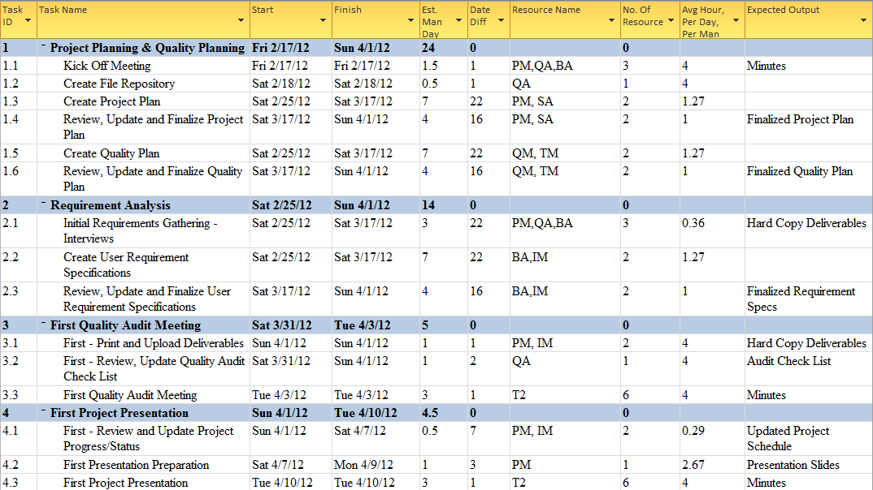

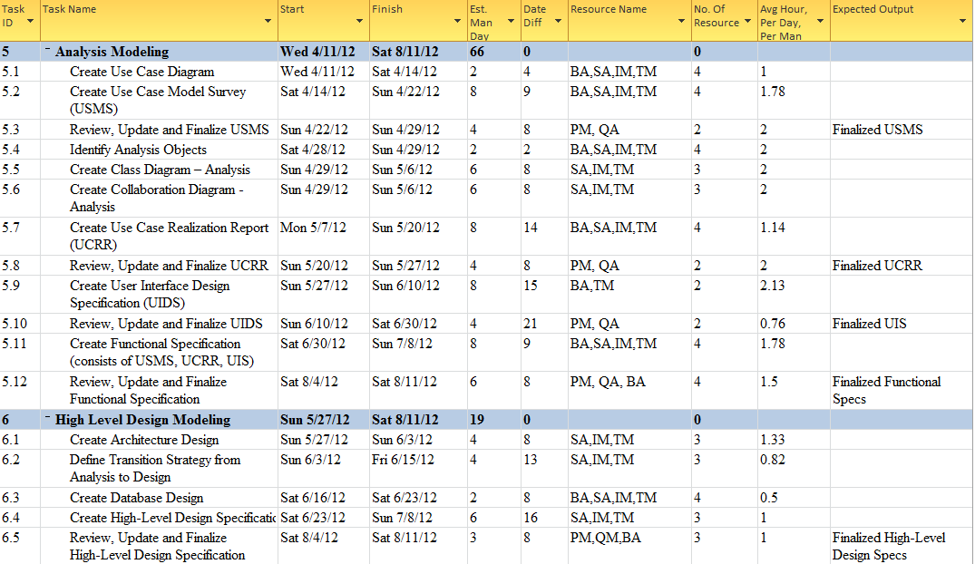
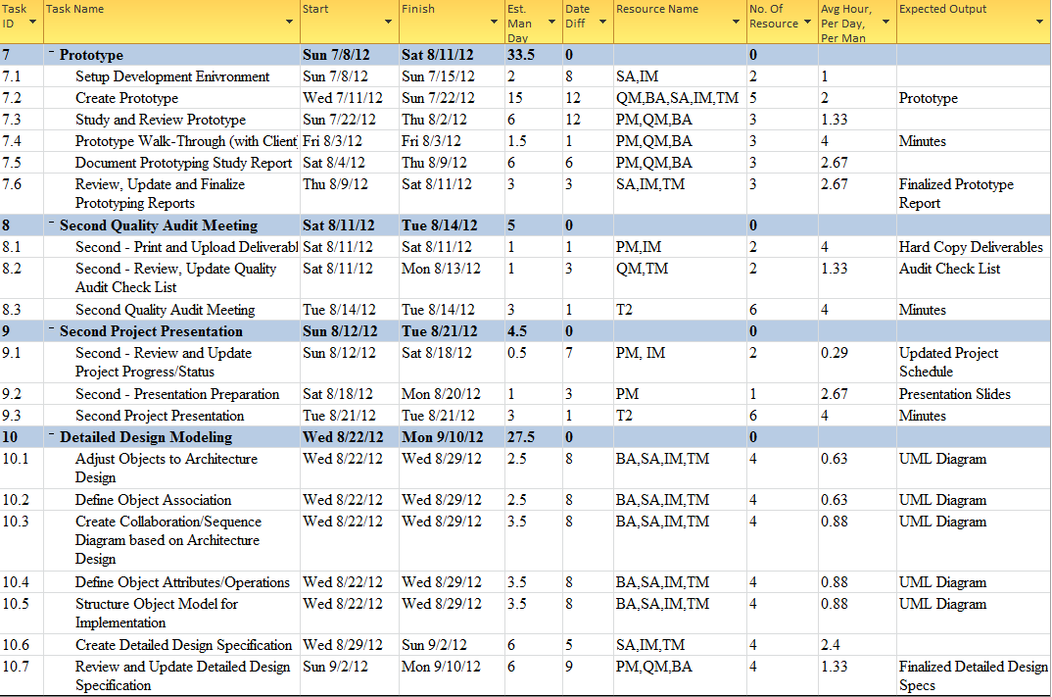
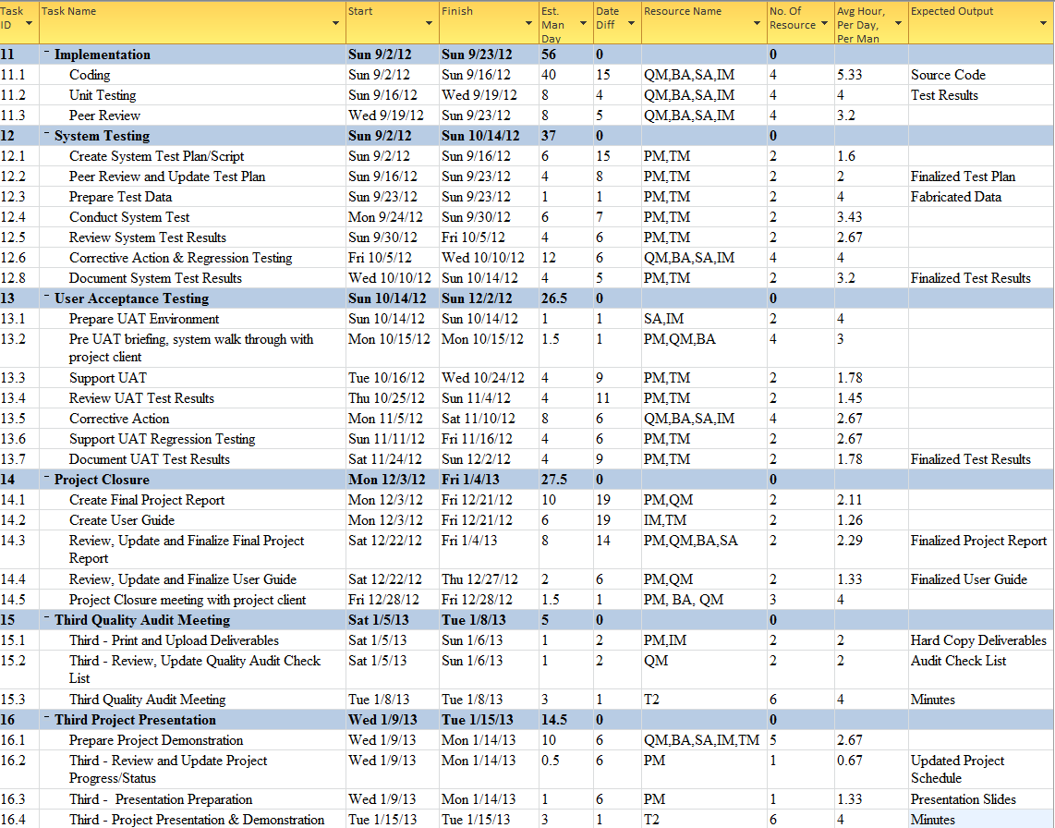

10.8 Detailed Work Breakdown Structure – Gantt chart

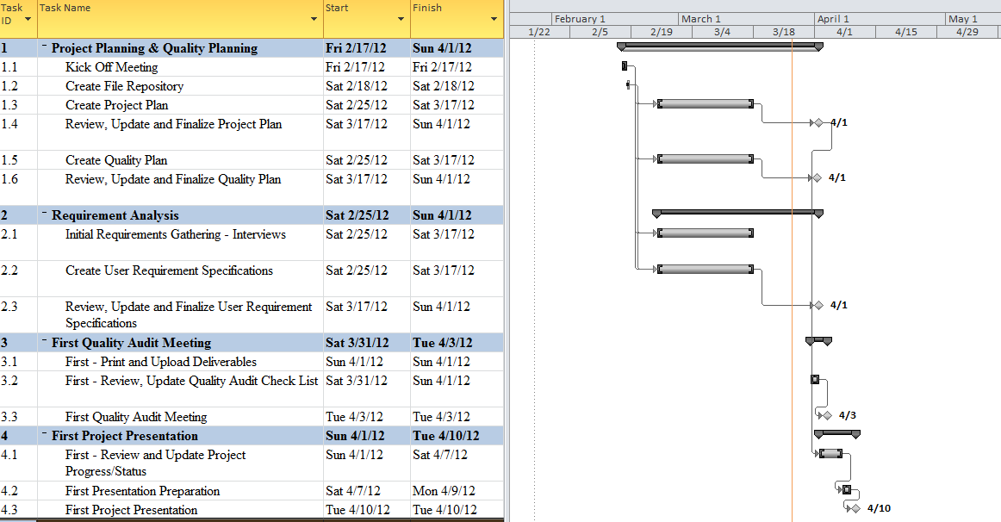
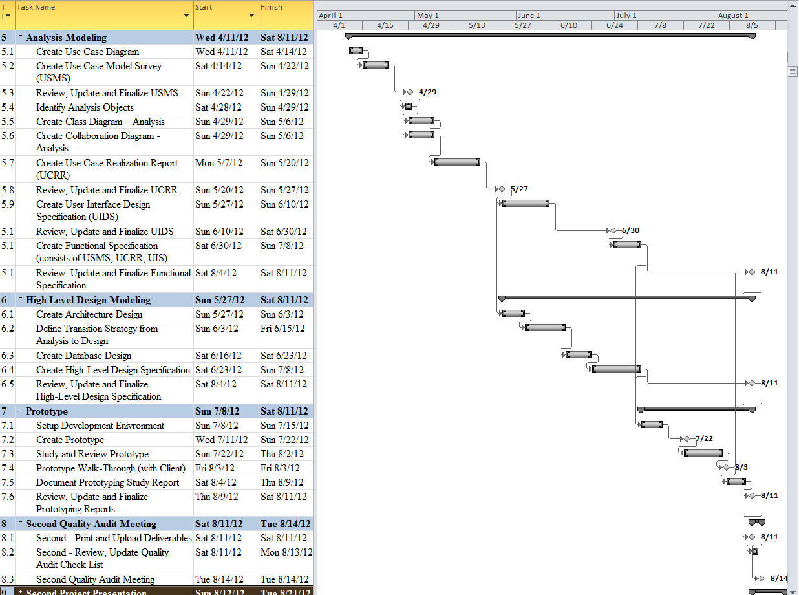
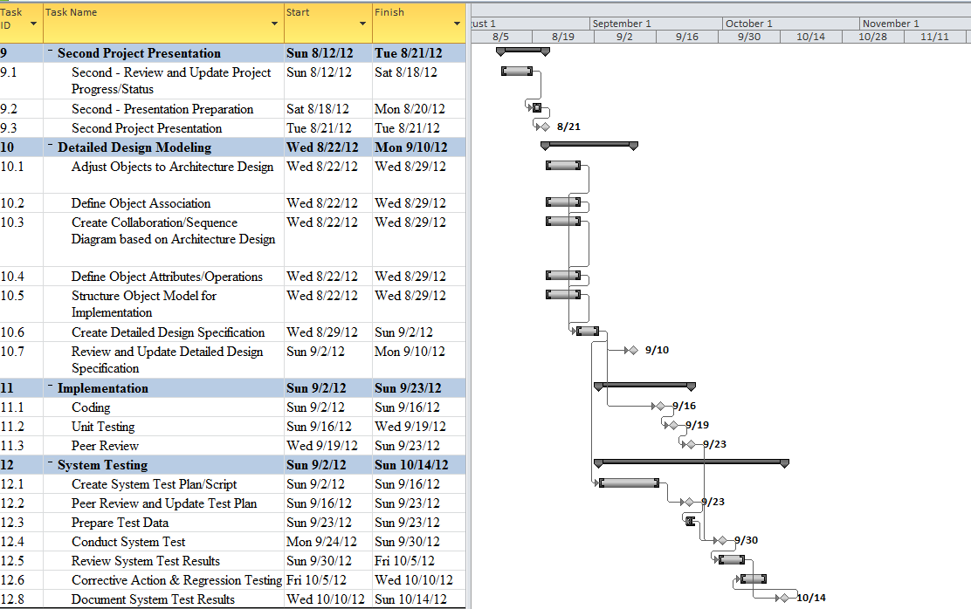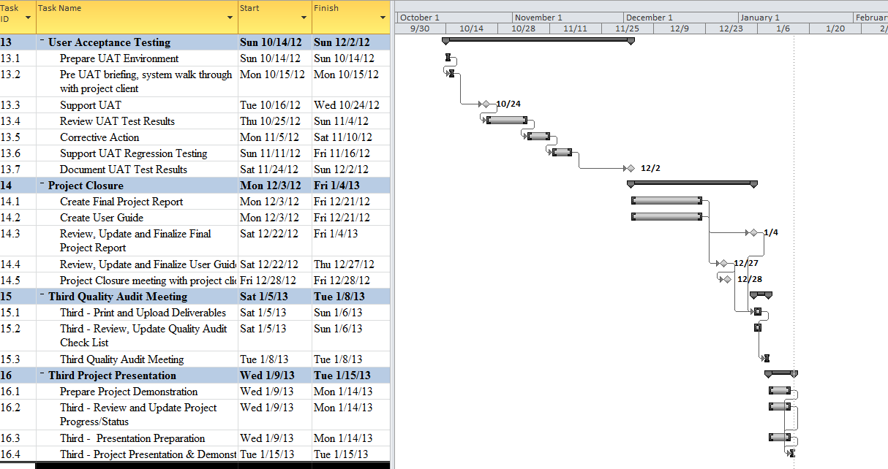

10.9 Risks Questionnaires

SN | Risk | Description | Consequences
1 | Team member departure and unavailability | There is a possibility that some team member may leave the team before the project is completed or may not be available when as initially expected. | - Other team members will have to take on the tasks left over by the leaving member. Those who took over the tasks may not have the complete knowledge required to continue the task.  - The remaining team members maybe overloaded as each member will have to take on the tasks left over by the leaving member  - if a team member needs to temporary take off from the project for longer than 2 weeks (oversea work commitment), other Team member will have to temporary stand in and continue on the task else the team may not meet the timeline for some deliverables.
2 | Project client commitment to the project and availability | This project will last for close to a year. The project client may lose interest and commitment to the project. There is also a possibility that the project client have to be on long leave e.g. maternity and unable to provide the required support to the project | - The team will lose support from the project client.  - In worst case, the project may not continue if the project client refuses or unable to provide support required from the project.
3 | Insufficient hardware resource | Only 1 ISS Server is provisioned for this project. There is a possibility that the server may breakdown | - The project may not move if no proper server environment is available
4 | System portability risk | The system may not run well in all browsers. This is due to different browser may interpret javascript, css and html differently | - System usability issue.
5 | Dependency on third-party library and lack of experience in third-party library | The third-party library may have limitation the team is not aware of. | - The system may be buggy  - The solution architect may have to redesign the system  - The team member may required more effort to develop the system than initially expected. This may have an impact on the project schedule
6 | Lack of experience in UI design for Mobile Website | None of the member have experience in designing UI for mobile Website | - Users may refuse to use the system because of its poor UI design
7 | Uncertainty/insufficient requirements | During the kick off meeting, user is uncertain of what they want in the system. The project team has to be pro-actively providing suggestions to the user. | - The system may not value add to the client business  - The system may lack the “intelligent” and “complexity” factor required by MTECH project

10.10 Risks Techniques

SN | Risk | Control Type | Techniques
1 | Team member departure and unavailability | Risk Transfer | - Every project member will undertake a primary and secondary role. E.g. Team Member Alvin will have a primary role as a Quality Manager and Secondary role as a Project Manager. Alvin will have to take on the PM responsibility should the current PM leaves the team or took long offs from the project
1 | Team member departure and unavailability | Risk Avoidance | - The man day estimated for each member should not exceed 70 days. This will help to ensure that the members will not be severely overloaded should there be a case where they need to take on leaving member’s teak.
1 | Team member departure and unavailability | Risk Minimization | - Anticipate all oversea leaves, marriage plan, baby plan, relocation plan etc and factor these to schedule and effort planning
2 | Project client commitment to the project and availability | Risk Minimization | - Continuously keep the project client updated with the project progress and future plans. Understand that the requirements will change over a long period and be open minded and flexible to these changes while ensuring that the change will not significantly affect the project schedule and effort
2 | Project client commitment to the project and availability | Risk Transfer | - Request for a covering officer from project client. Keep the covering officer updated with the project progress and plans.
3 | Insufficient hardware | Risk Transfer | - The server environment will be replicated and back up on a solution architect personal notebook. If the main server fail to work. Solution architect personal notebook will be activated immediately to avoid any delay due to the unavailability of server environment.
4 | System portability risk | Risk Insurance | - Select 2 most widely used desktop browser and mobile browser. Design and test the system on the selected browsers. Inform project client that this is a limitation faced by all web application. Although it may not run on all browsers, it should run on the major browsers
5 | Dependency on third-party library and lack of experience in third-party library | Risk Minimization | - Factored in the effort required by the solution architect to study third-party library
5 |  | Risk Minimization | - Build and test the prototype to using the third-party library.
6 | Lack of experience in UI design for Mobile Website | Risk Minimization | - Factored in the effort required by the business analyst to study mobile website UI design.
6 | Lack of experience in UI design for Mobile Website | Risk Minimization | - Business analyst to create a UI specification. Build a prototype to test the UI usability. Analyze user’s feedback on prototype and incorporate the change when required.
7 | Uncertainty and insufficient requirements | Risk Avoidance | - Perpetually brainstorm for more creative ideas
7 | Uncertainty and insufficient requirements | Risk Avoidance | - Seek advice from ISS mentors
7 | Uncertainty and insufficient requirements | Risk Minimization | - Create and study prototype to discover potential improvements that can be made to the system

11. Approval Record
Approval Record
Project Name MasterCard Personal Expense Management System
Document Ref MPEMS_PM-1.2.1
Approved by | Date
The document authorisation appears on the title page.
The structure of the publication is logical.
The distribution list is correct.
The title page is signed.
Calculations appear reasonable, are neatly presented and have been checked.
Theory and formulae are correct and properly applied.
Illustrations are relevant, readable and logically placed.
There are no typographical errors.
Units are consistent throughout.
The security classification is correct.
There are no obvious omissions.
The document complies with the Client's requirements, however specified.
Responsibility is accepted for all opinions, conclusions and recommendations.
The document does not run counter to company policy.

12. Amendment History
Version | Section | Notes of Amendments or Changes
0.1 | - | Initial Draft
0.1a | Section 2 | - Revised Work Plan
0.1a | Section 3 | - Revised Project Approach
0.1a | Section 5.2 | - Revised Project Milestones
0.1a | Section 10.6 | - updated total man days
0.1a | Section 10.8 | - Add project timeline gantt chart
0.1a | Section 10.7 | - Revised WBS Task details to add in average hours per day
0.1b | Section 10.10 | - Revised Risk techniques
0.1b | Section 10.1 | - Revised FPC Count
0.1b | Section 11 | - Added Amendment History based on quality plan
0.1b | Section 2, 3 | - Revised Work Plan and Project approach to eliminating overlapping of description
1.0 | - | - Final review. Updated document format to ensure consistency among all project documents. Checked for typo and erroneous statement
1.0 | Section 4.2 | - Updated COCOMO estimates due to changes in FPC
1.0 | Section 1.4 | - Updated project organization

End of Project Plan

